REPORT FOR: | HEALTH AND WELLBEING BOARD
Date of Meeting: | 10 January 2019
Subject: | INFORMATION REPORT – Non-Cancer Screening Update
Responsible Officer: | Kathie Binysh, Head of Screening  NHS England (London)
Exempt: | No
Wards affected: | All
Enclosures: | Non

Section 1 – Summary

This report sets out the performance of the adult non-cancer screening programmes for the Harrow population. These services are commissioned by NHS England

FOR INFORMATION

Section 2 – Report

Adult Non-Cancer Screening Programmes
- Abdominal Aortic Aneurysm Screening Programme (AAASP)
- Diabetic Eye Screening Programme (DESP)

Abdominal Aortic Aneurysm Screening Programme

Background
The NHS AAA screening programme was introduced in England between 2009 and 2013 following the MASS (Ashton et al 2002) study which found that offering men ultrasound screening in their 65th year could reduce the rate of premature death caused by a AAA rupture, by up to 50 per cent.

Men are automatically invited for screening in the year they turn 65. Men who are older than 65 that have not been screened can opt-in through self-referral. Men with a screen detected aneurysm of 5.5 cm and above are referred into the local vascular network centre for surgery. Men with smaller aneurysms measuring between 3.0 and 5.4 cm are monitored and managed through the quarterly or annual surveillance screening pathway by the AAASP.

Commissioning and Service Provision
The North London AAASP (NLAAASP), provided by InHealth, commenced on 1st April 2018 following re-procurement by NHS England London region. The new programme incorporates the three previous north London AAA Screening Programmes (NWL, NCL and NEL) and includes 20 CCGs and 19 local authorities.

The key stakeholder relationships for AAA Screening programmes are the designated Vascular Network referral and treatment centres, in North London, these are Barts Health, The Royal Free and for North West London, Imperial College Healthcare NHS Trust. The new NLAAASP has maintained the existing, established and nationally approved referral and treatment pathways for screen detected AAAs. Men with screen detected aneurysms in North West London continue to be referred to the NWL Vascular service at Imperial, unless they exercise their choice to be referred to an alternative vascular service.

Performance

Context

The London-wide procurement of the AAA programmes sought to improve workforce resilience, ensure equitable funding across London and provide contract stability (previously contracts were only being offered on a year to year basis). Stable contracts allow service providers to plan and deliver meaningful programmes of continual service improvement.

It is an unfortunate consequence that any change programme of this scale, brings periods of uncertainty. During these periods it is not uncommon that people working within services may choose to seek alternative employment. Performance of AAA screening programmes has been impacted in the 2017/18 reporting year due to the programme of procurement.

A consequence in NW London was that the previous NWL AAA programme had been unable to invite the full eligible cohort within the expected timescale. The new provider has addressed this and all men have now been invited and screening invitations are back on track.
Current performance
The Public Health England Quality Assurance visit reports stated that in 2016/2017, uptake was 71.1% compared to a slightly higher 72.5% in 2015/2016. Aortic abdominal aneurysms (AAA) detection rate for North West London is similar to London average (0.8%) but lower compared with the national average (1.1%).
As previously mentioned, London uptake during the 2017/18 screening year suffered because of workforce capacity challenges brought about by the procurement. Figure 1 shows uptake of AAA screening at the end of the year for NWL, London and England. However, we anticipate that these will be back to pre-procurement levels in 2018/19.
Figure 1:
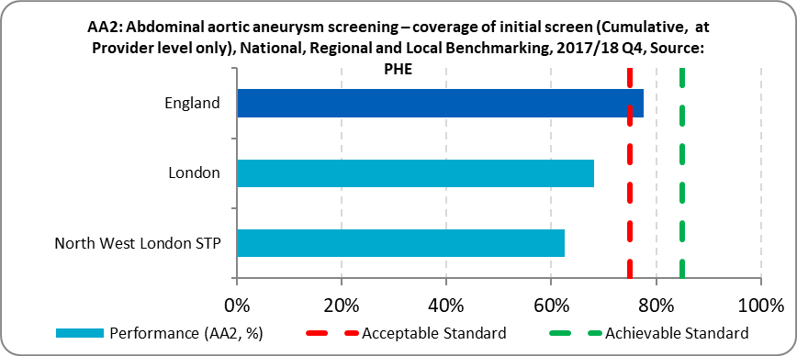
Source: NHSE Business analytics Screening KPI performance data report

Table 1 shows a summary of coverage performance, plus the two additional KPIs that measure attendance for the at-risk group of men who have been placed on an aneurysm surveillance programme (AA2 = annually, AA3 = quarterly), at Q4 2018/18.

Table 1: Adult screening programme KPIs: Q4 2017 to 2018
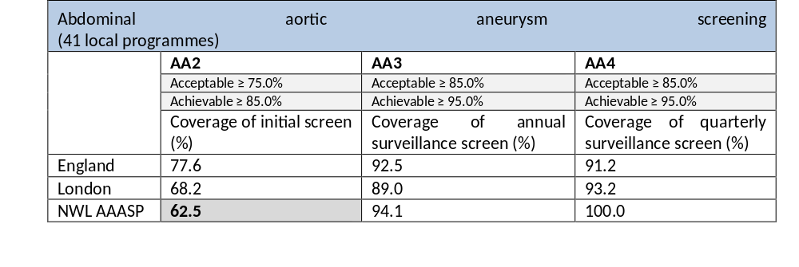 Source: PHE Screening: Q4 2017-18 KPI data submissions (01 January to 31 March 2018)

Managing performance
NHSE commissioners worked closely with the exiting provider to ensure the impact of reduced capacity on the service offered was minimized. However, on completion of the NWL AAASP in March 2018 there were 2,300 invitations (first and second) that had not been issued, due to a planned reduction of offered letters, ensuring pathway delivery for those attending remained safe and of high quality. This activity was transferred to the new NL AAASP in April 2018.
*Men who had previously been identified as requiring further surveillance were prioritised and all were offered appointments in a timely manner.
InHealth

InHealth began providing AAA service across North London from April 2018, although there was a period of down time at the start of the contract to support handover, staff induction and initial administrative scheduling. 2,300 appointments, outstanding from the previous NWL AAASP, were identified as priority activity. As of October 2018, all men from this group have now been offered two invitations to attend AAA screening as per national recommendations.

2018/19 data is currently under review by NHSE commissioners, London region PHE Quality Assurance leads and the service provider. Recovery management plans have provided assurance that the full 2018/19 cohort will have received invite no later than June 2019, as per the requirements of the service specification.

Improvement plans will be developed following full recover and completion of the first contract year.

Diabetic Eye Screening Programme
Background
Evidence shows that early identification and treatment of diabetic eye disease could reduce sight loss. Public Health England coordinate nationally the delivery of a diabetic eye screening programme (DES) that offers annual (or more frequently where clinically necessary) screening to the eligible population.
The eligible population for DES is all people with type 1 and type 2 diabetes aged 12 or over.
People already under the care of an ophthalmology specialist for the condition are not invited for screening.
The national diabetic eye screening programme offers pregnant women with type 1 or type 2 diabetes additional tests because of the risk of developing retinopathy.
Screening gives people with diabetes and their primary diabetes care providers information about very early changes in their eyes.
Early warnings allow people to take preventative action to stop serious retinopathy developing.
Untreated diabetic retinopathy is one of the most common causes of sight loss. When the condition is caught early, treatment is effective at reducing or preventing damage to sight.

Commissioning and Service Provision

The NHS DESP Screening Programme is coordinated and led nationally by Public Health England.
NHS England (London) commission the provision of an end-to-end screening service for the eligible population of the national DESP. In London, this currently comprises of five Provider organisations delivering to an eligible population of approximately 500,000 patients per year. The organisation responsible for the population of North West London is Health Intelligence.
Within London, providers are paid a standard tariff and have a five-year contract, with an option to extend for a further two years. The contract is for delivery of the national service specification, which includes three national KPIs and several screening pathway standards. Assurance is received through quarterly multi-disciplinary Programme Performance Boards that are facilitated and chaired by the commissioning team.

Treatment centres and pathways are commissioned by CCGs.

Performance
Figure 2 shows how uptake of diabetic eye screening is better in London than in any other commissioning region in England. In North West London, uptake is 90.5%, the highest of all STPs in the region.
Figure 2: Uptake of diabetic eye screening by STP, region and national
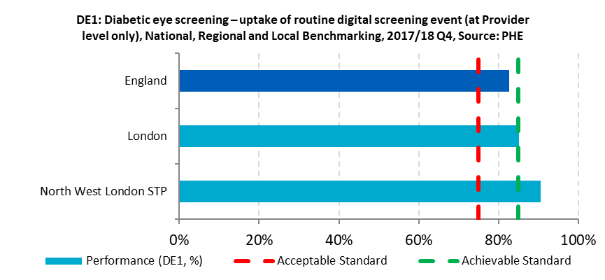

Figure 3 shows that within NWL STP, Harrow and Hillingdon have the highest uptake in their diabetic population, both achieving a 92% uptake rate for screening following invite.

Figure 3: Uptake of diabetic eye screening by CCG within NWL STP
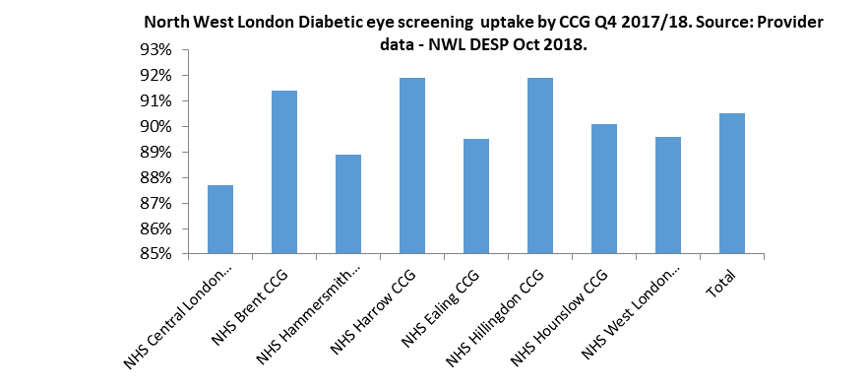

Health Inequalities
NHS England (London) commissioners are seeking to commission the development of a health inequalities reporting function to be included in the DESP screening programme software. This aims to support the provision of high quality, multi-source data at programme, CCG, LSOA and GP practice level.
The reporting function will look at service performance data and other data sources simultaneously, allowing us to develop an understanding of what wider determinants are impacting a patients’ likeliness to attend for screening when invited. A targeted health inequalities strategy will then be developed and delivered by the screening programme and their stakeholders.
It is anticipated that the reporting function will be available by Q2 2019/20.

Section 3 – Financial Implications

NHS England is responsible for commissioning screening programmes.

Section 4 - Equalities implications

Was an Equality Impact Assessment carried out? No

Section 5 – Council Priorities

The Council’s vision:

Working Together to Make a Difference for Harrow

- Making a difference for the vulnerable
- Making a difference for communities

STATUTORY OFFICER CLEARANCE
(Council and Joint Reports

Not applicable

Ward Councillors notified: | NO

Section 7 - Contact Details and Background Papers

Contact: Kathie Binysh Kathie.binysh@nhs.net

Background Papers: None

